Honors Algebra 2 Online Textbook Access
Follow the steps below to sign up for online access to our textbook.
- To access the SpringBoard Digital site, please visit http://booneky.springboardonline.org and click “new to springboard?”

- Enter the access code PGPUPQ.

- Enter your information and generate your password.
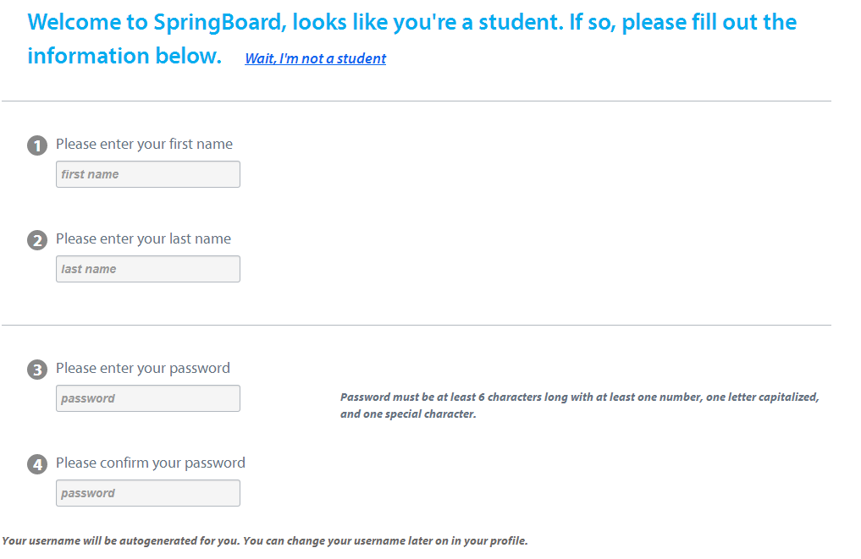

- Springboard will generate a username for you.
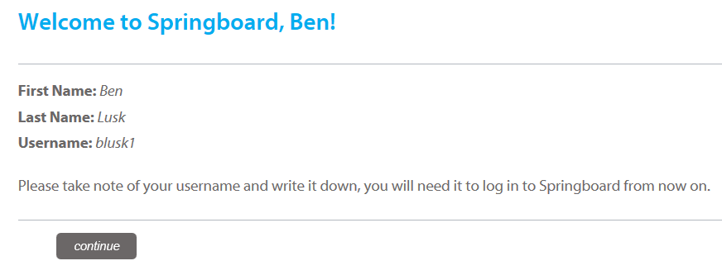

- Write down your login information below and place this page in your class binder.

- Click on MY BOOKSHELF to access the online text.
